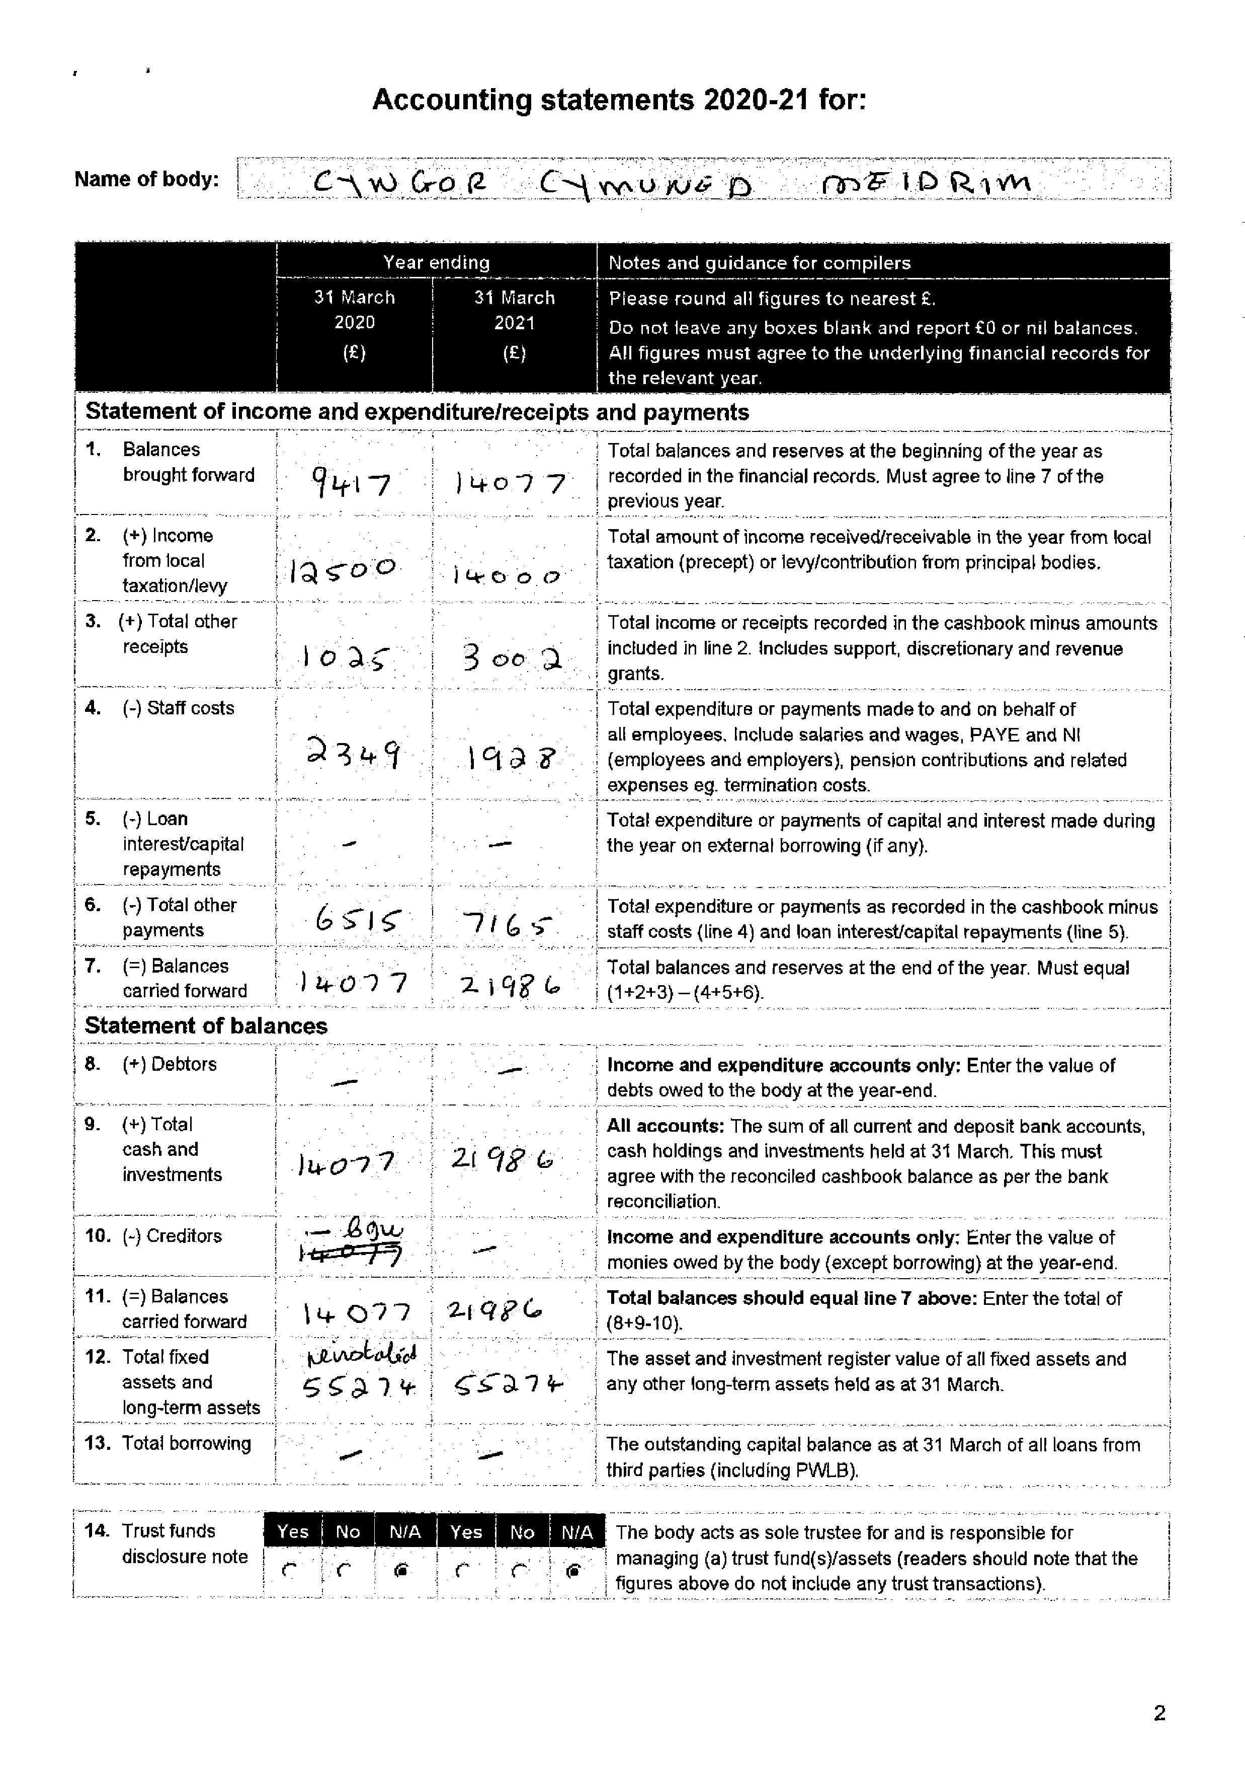
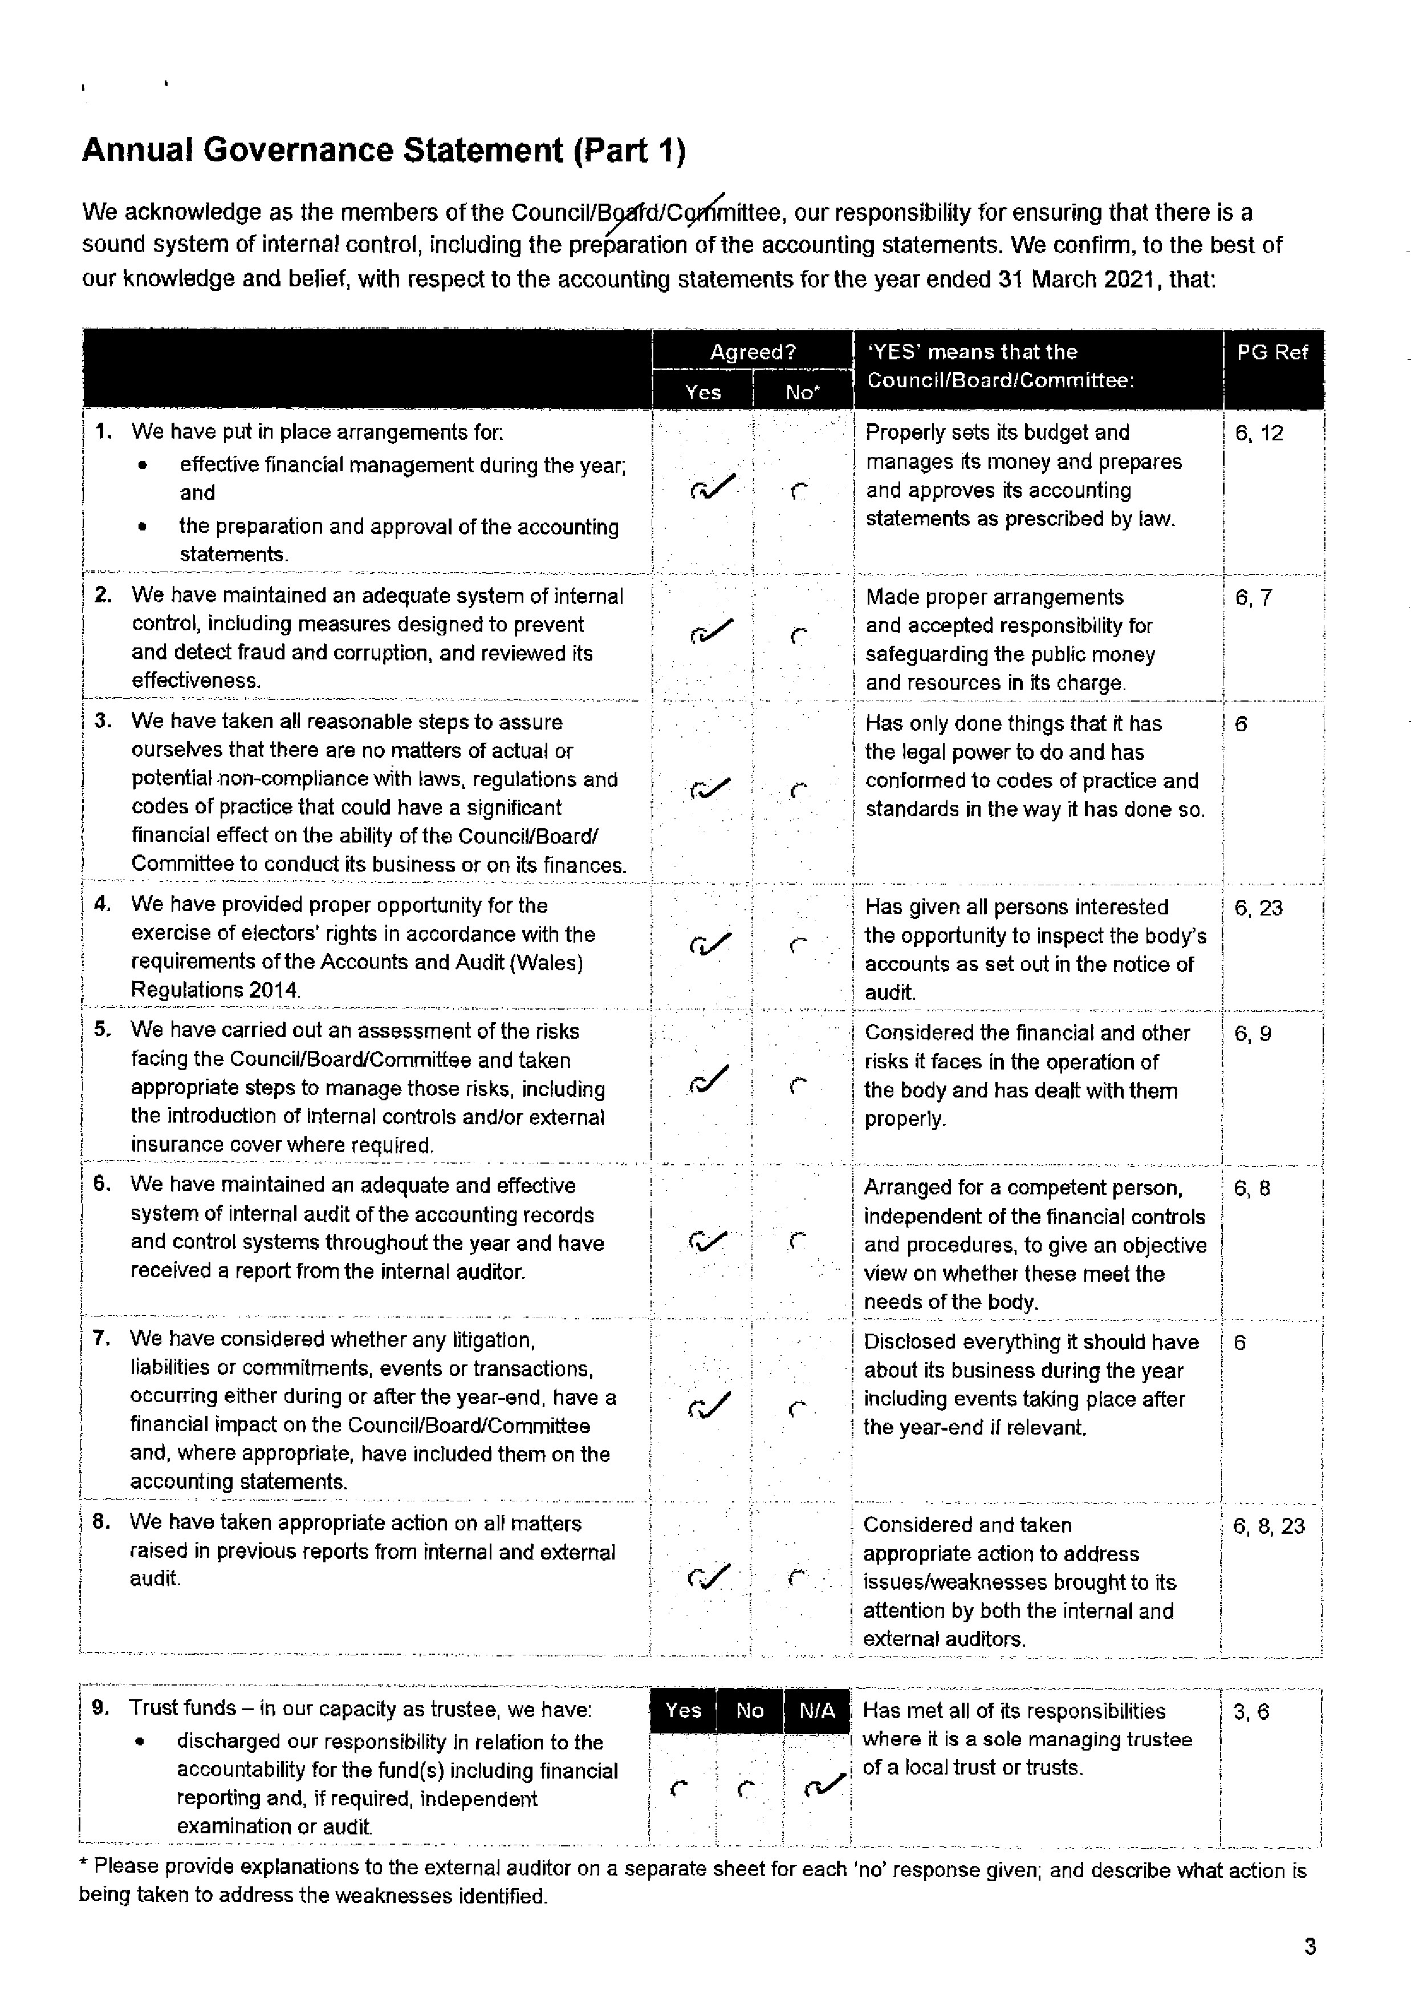
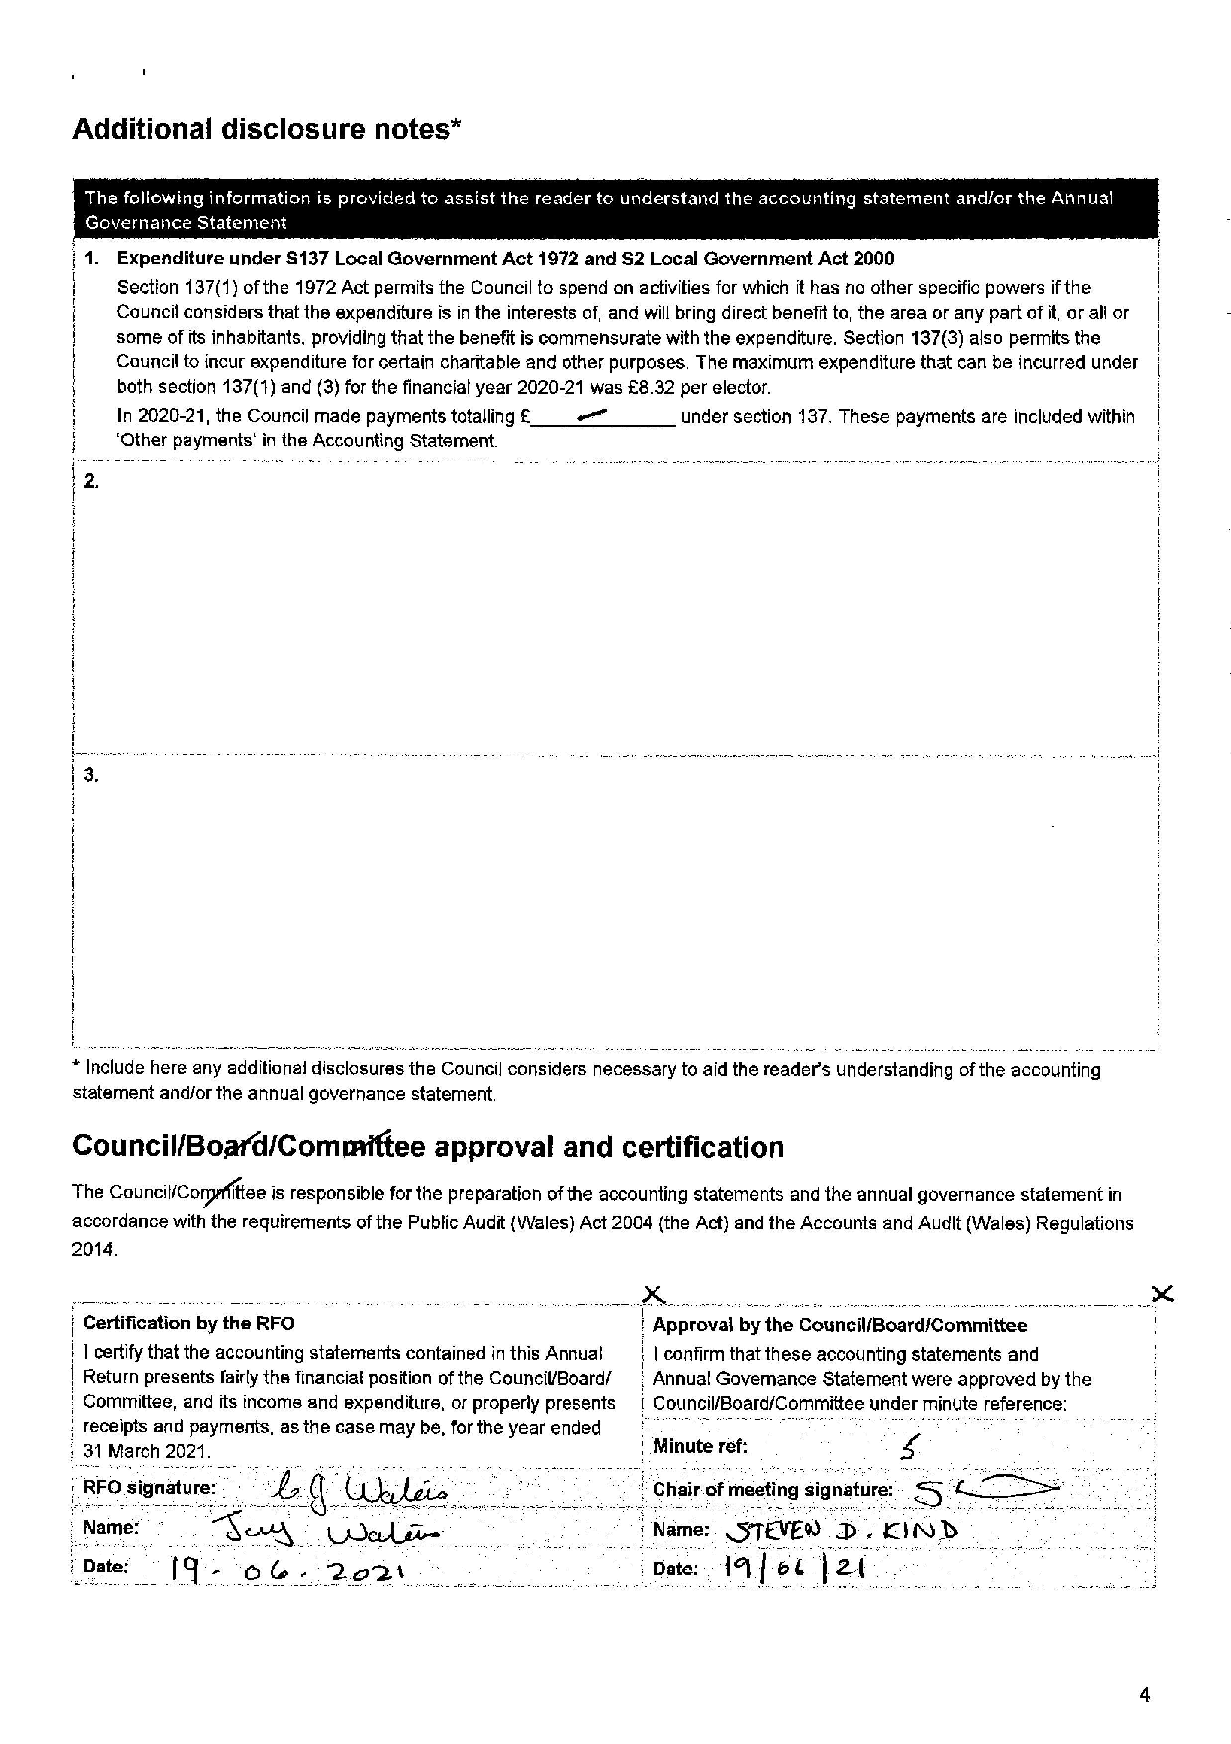

Auditor General for Wales’ Audit Certificate and report
I report in respect of my audit of the accounts under section 13 of the Act, whether any matters that come to my attention give cause for concern that relevant legislation and regulatory requirements have not been met. My audit has been conducted in accordance with guidance issued by the Auditor General for Wales.
I certify that I have completed the audit of the Annual Return for the year ended 31 March 2021 of:

Meidrim Community Council
Auditor General’s report
Audit opinion – Qualified
Except for the matters reported below in my Basis for Qualfication, on the basis of my review and subject to the matters and recommendations identified below, in my opinion no matters have come to my attention giving cause for concern that in any material respect, the information reported in this Annual Return:
- has not been prepared in accordance with proper practices;
- that relevant legislation and regulatory requirements have not been met;
- is not consistent with the Council’s governance arrangements; and
- that the Council does not have proper arrangements in place to secure economy, efficiency and effectiveness in its use of resources.
Basis for Qualification
Annual Governance Statement
In my opinion, the Annual Governance Statement is inconsistent with the Council’s governance arrangements for the year:
- Assertion 3 – noncompliance with laws, regulations and codes of practice. The Council has not provided evidence that a
budget has been set in accordance with the Local Government Finance Act (1992) and that the precept has been set in line with the budget. The Act requires the Council to take into account its level of reserves when setting its budget requirement. We recommend that the Council sets a budget in accordance with the relevant regulations and codes of practice.
Other matters arising and recommendations
There are no further matters that I wish to draw to the Council’s attention.

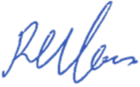  Richard Harries, Director, Audit Wales  For and on behalf of the Auditor General for Wales | Date: 30/11/2023

