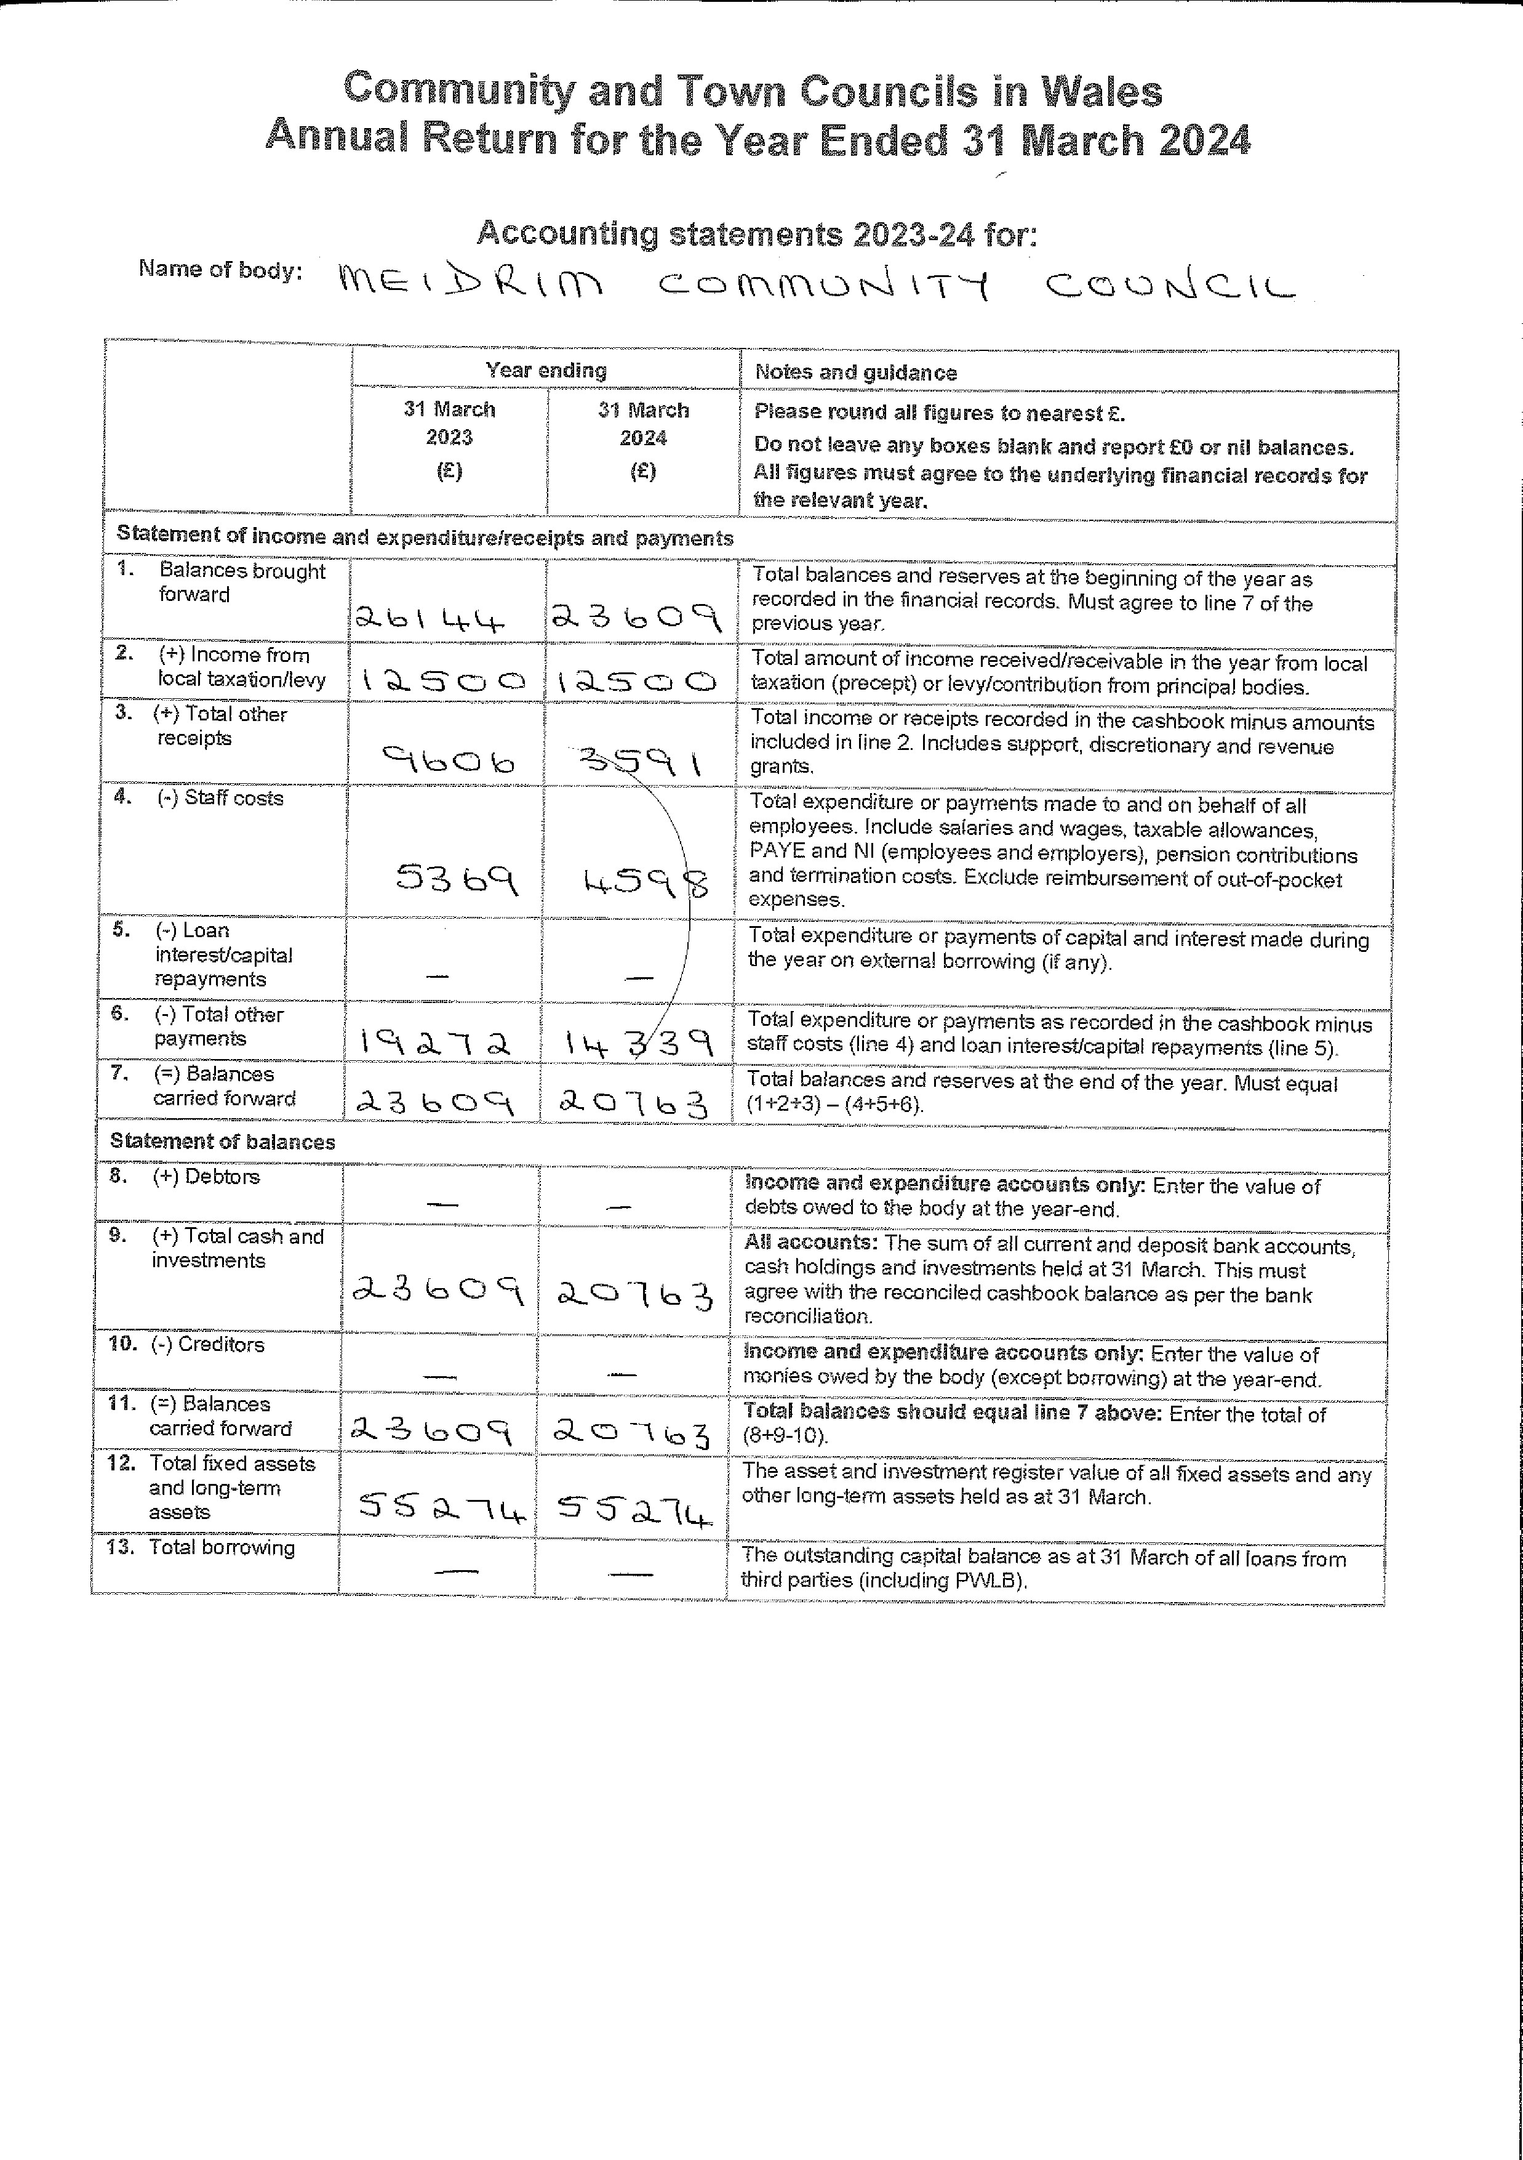
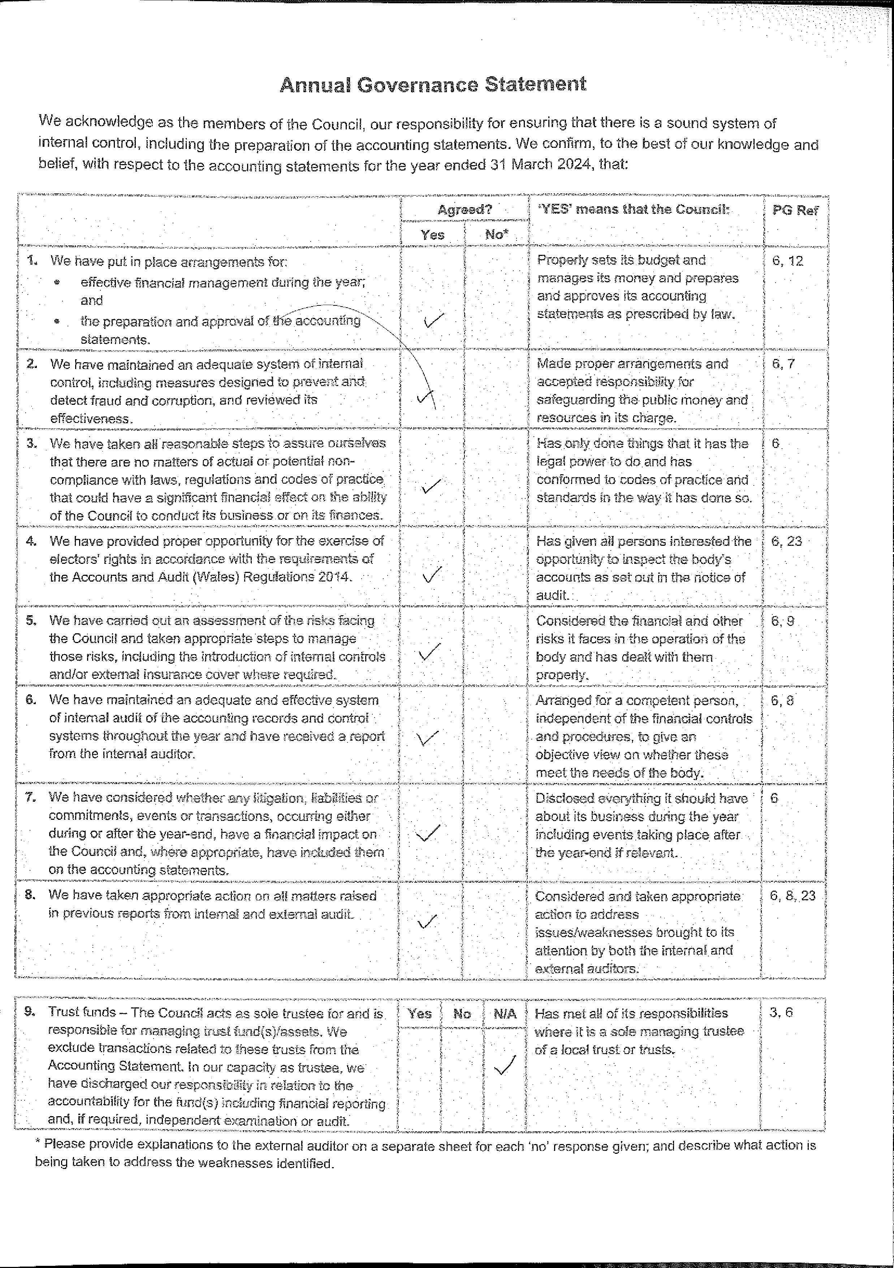
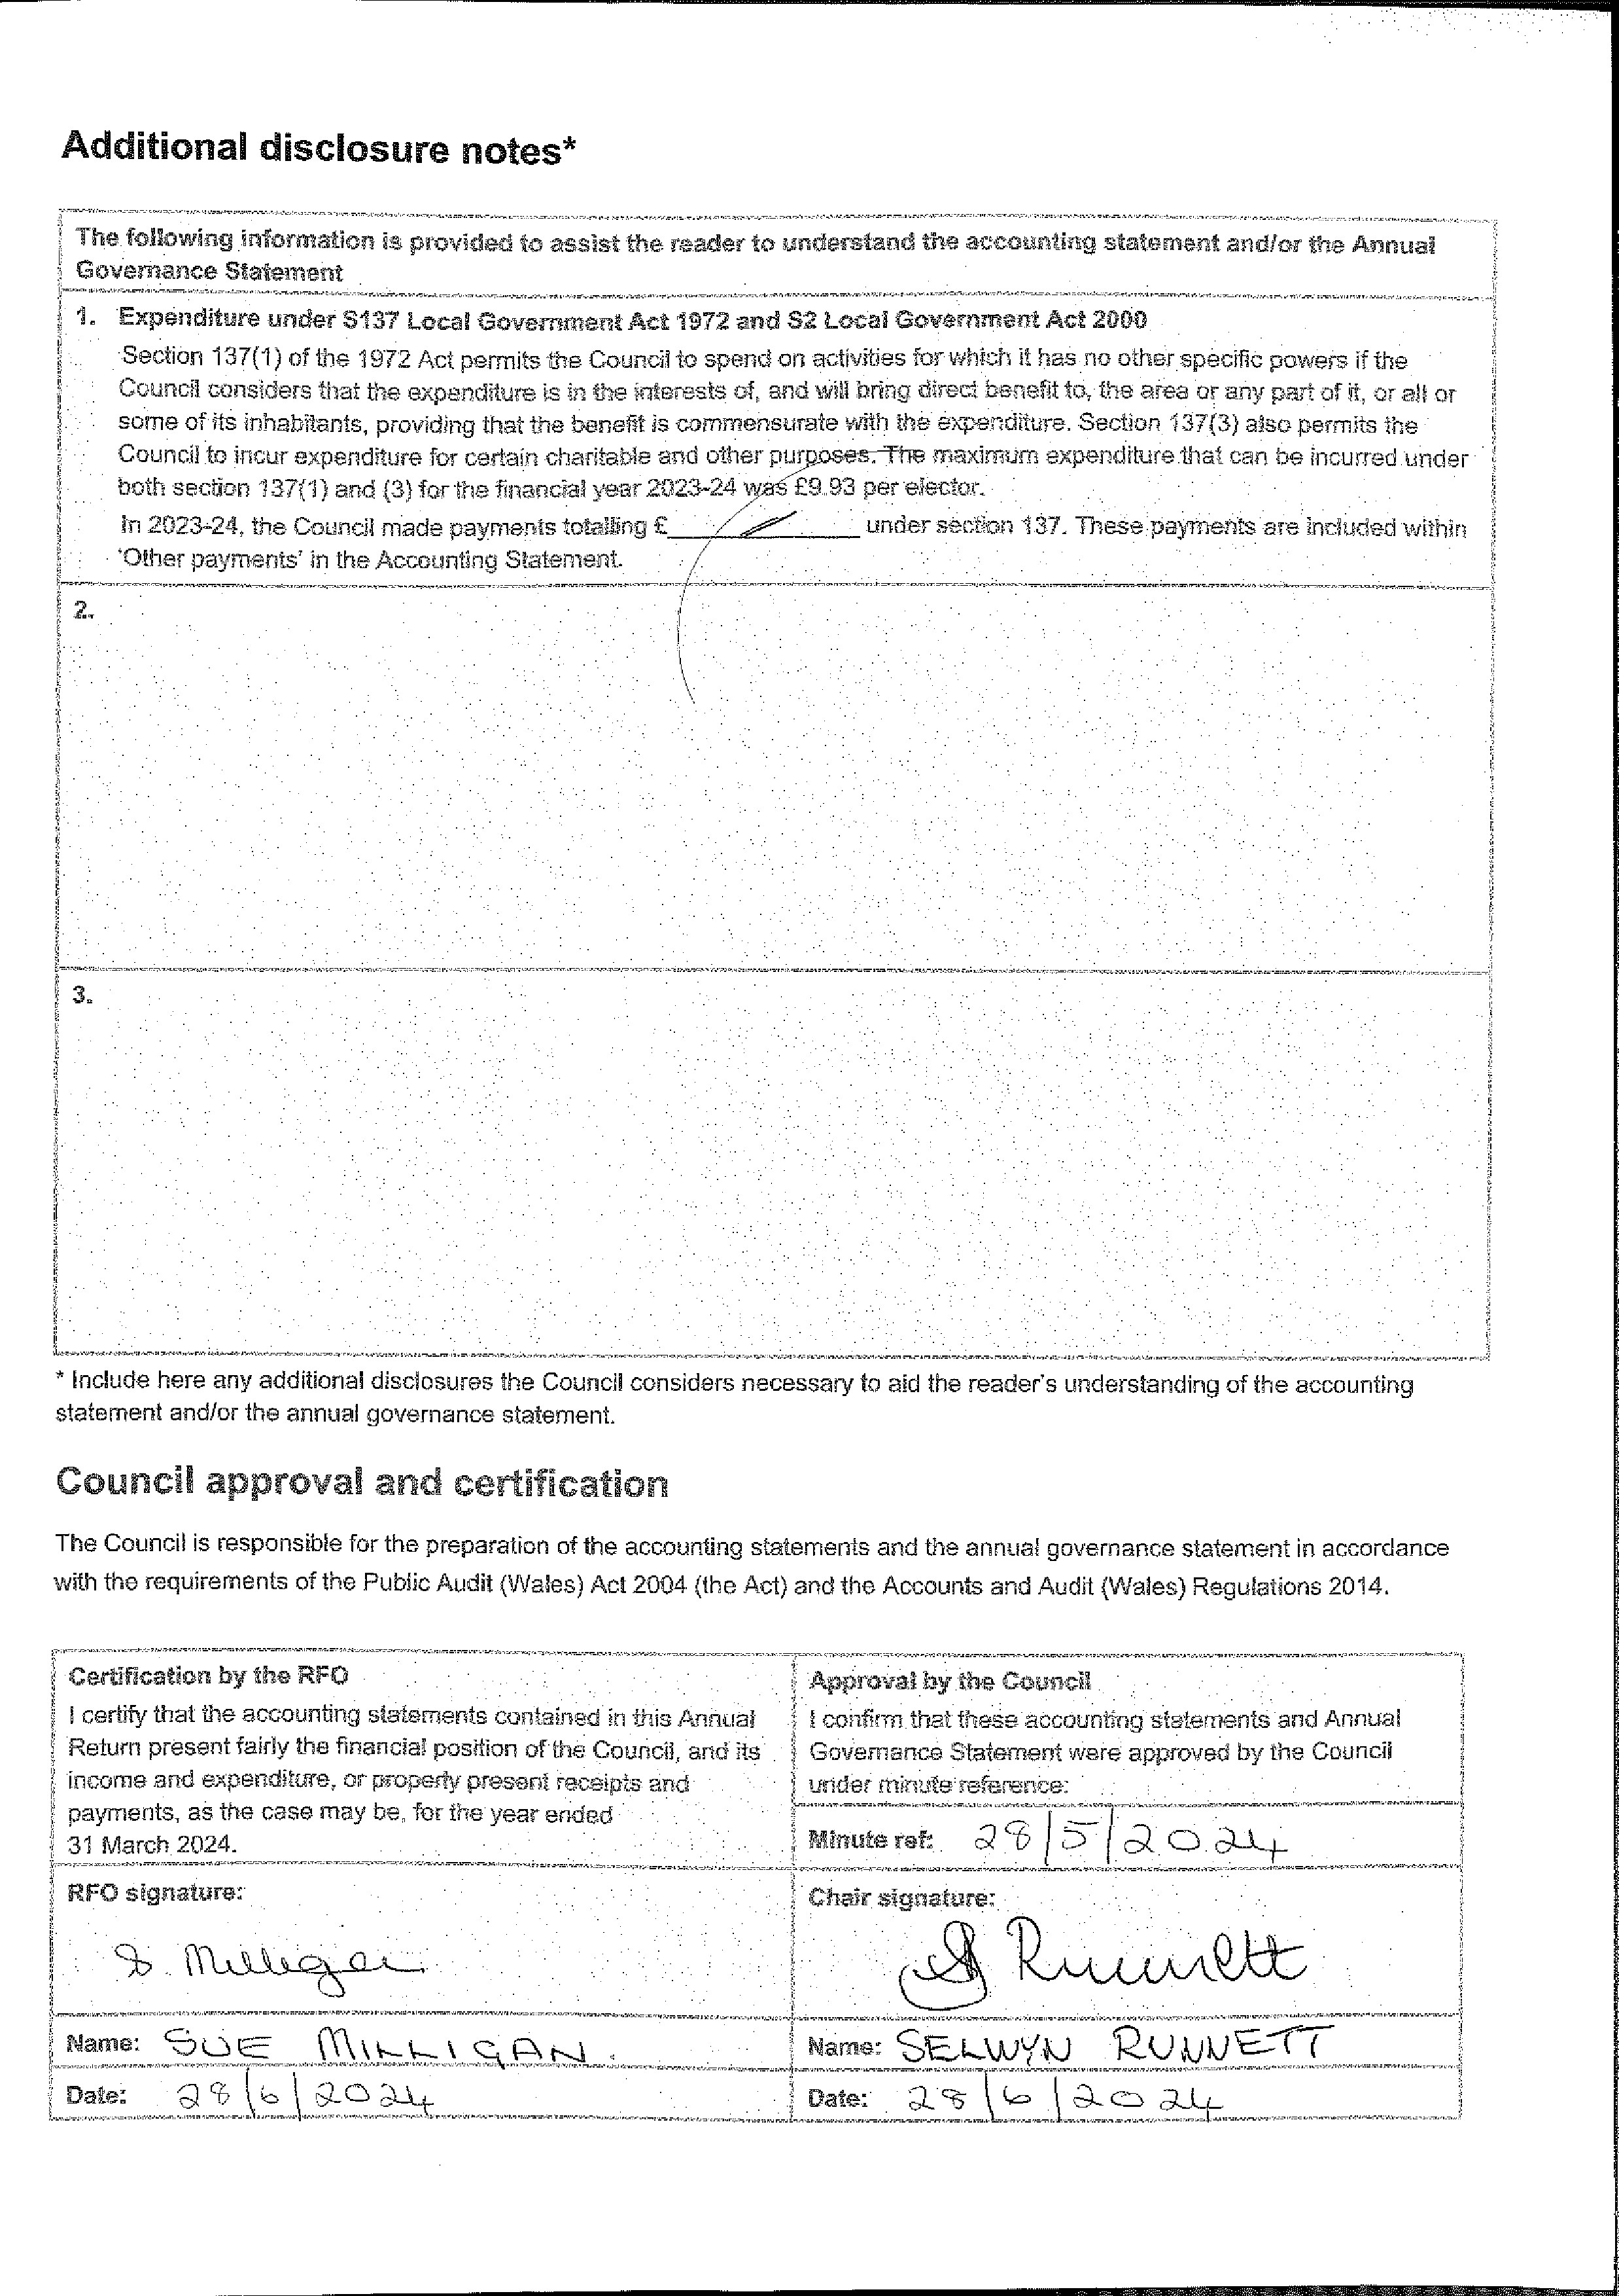

Auditor General’s report and audit opinion
I certify that I have completed the audit of the Annual Return for the year ended 31 March
2024 for DĞŝĚƌŝŵ Community Council. My audit has been conducted on behalf of the
Auditor General for Wales and in accordance with the requirements of the Public Audit (Wales) Act 2004 (the 2004 Act) and guidance issued by the Auditor General for Wales.
Audit opinion: Unqualified
On the basis of my audit, in my opinion no matters have come to my attention to give cause for concern that, in any material respect, the information reported in this Annual Return:
- has not been prepared in accordance with proper practices;
- that relevant legislative and regulatory requirements have not been met;
- is not consistent with the Council’s governance arrangements; and
- that the Council does not have proper arrangements in place to secure economy, efficiency and effectiveness in its use of resources.
Other matters and recommendations

There are no further matters I wish to draw to the Council’s attention.
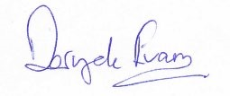  Deryck Evans, Audit Manager, Audit Wales  For and on behalf of the Auditor General for Wales | Date: 27/11/2024
Page 1 of 1 - Auditor General’s report and audit opinion - please contact us in Welsh or English / cysylltwch â ni’n Gymraeg neu’n Saesneg.

